DELEGATE HANDBOOK

Nedbank – Open Procurement Doors! 2023

WELCOME AND INTRODUCTIONS
Thank you for choosing Henley Business School as your learning partner. We are delighted to be sharing this learning journey with you.
We know that skills build a career, build a life and build a country. All we care about is that you grow – whilst and after you are with us so that you can make a contribution to your work, create value for your clients and those you serve.
We are committed to building the people, who build the businesses that build Africa.

Jon Foster Pedley – Dean and Director

Deep and lasting learning happens when we come together to share a series of rich, developmental experiences – something magical happens.
Just imagine the power of these moments translated into action within the workplace. Shared with our teams and stakeholders. High-performing teams get things done, effectively.
What more can one ask for? Make it count.

Linda Buckley – Head of Leaning Experience and Executive Education Director

Meet the Henley team, who are here to assist you:
Programme Director Frans van der Colff Frans@henleysa.ac.za
Senior Programme Manager John-Martin C johnmartinc@henleysa.ac.za
Programme Manager Cleo Nyoni cleopatran@henleysa.ac.za
Programme Coordinator Nazeer Morat nazeerm@henleysa.ac.za

Programme dates:
Attendance dates
May 15 – Monday (7:00-8:30)
May 17 – Wednesday (7:00-8:30)
May 22 – Monday (7:00-8:30)
May 24 – Wednesday (7:00-8:30)
May 29 – Monday (7:00-8:30)
May 31 – Wednesday (7:00-8:30)
June 5 – Monday (7:00-8:30)
June 7 – Wednesday (7:00-8:30)
June 12 – Monday (7:00-8:30)
June 14 – Wednesday (7:00-8:30)

The assignments and corresponding activities are reflected below. This is your assessment schedule indicating the assignments and their due dates.

ALL ASSESSMENTS
Module | Due Date
Assignment 1 | 29 May 2023
Assignment 2 | 15 June 2023
Pitch Battle Video | 21 June 2023
Pitch Battle (Finalists) | 18 July 2023

REMEMBER | - Diarise the due dates  - Make sure that you block out time along the way, so that you aren’t rushing to finish | Complete

PERSONAL DEVELOPMENT PHILOSOPHY

The fundamental framework of the programme has been developed on the philosophy of both horizontal and vertical growth.
- Me
- We
- Work
- World
The concepts of ‘Me, We, Work, World’ adopt an inside-out leadership philosophy of focusing on developing self, then others, then developing the organisation which ultimately impacts society and the world we live in.
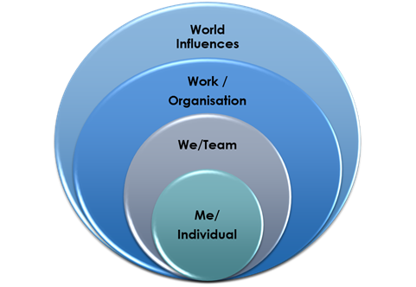

Individual Reflection Papers
Delegates are required to write a reflection paper on specific aspects of the growth and learning they have undergone during each study block; speaking to horizontal and vertical growth respectively. The briefing for each Individual Reflection Paper may be found in the assessment briefing for each block.

DEADLINES AND PENALTIES

A schedule has been provided indicating the due dates of assignments. Assignments must be submitted by 10:00 am on the date stipulated. Please note that the school policy regarding late submissions is that the learner/s concerned will receive a 5% deduction off their final result for every day that the assignment is late. (Saturday and Sunday included.) Please note that the school policy regarding non-submissions is that the learner concerned will receive 0% for an assignment resulting in the learner failing the module and in turn, not completing the Programme.

DISTINCTIONS

To pass an assessment with distinction, a learner must pass the assessment on the first submission and obtain a percentage (final mark) of 75%. To pass a module with distinction a learner must achieve an overall weighted average of at least 65% and pass all assessments on the first submission. To pass the programme with distinction, a learner must pass all assessments on the first submission with a final overall average for all the assessments of at least 75%.

Certification

In order to obtain a Certificate of Completion, students are required to:
- Attend all 10 sessions virtually. Students are encouraged to attend with their allocated cohort but can attend with the other cohort if needs be. This must be arranged the Henley Programme Manager
- Both reflective assignments must be submitted and receive a 50% pass mark. Assignment submissions as follows:
- Assignment 1 – Due 29 May 2023
- Assignment 2 – Due 15 June 2023
**These will be practical applications of work covered with a 300 word summary submitted**
- Submission of final Pitch Battle video – Due 21 June 2023

Students failing to meet all the above mentioned criteria will be eligible for a Certificate of Attendance, students are required to:
- Attend a minimum of 70% of all online sessions i.e. 7 sessions
- Both reflective assignments must be submitted and receive a 50% pass mark. Assignment submissions as follows:
- Assignment 1 – Due on 29 May 2023
- Assignment 2 – Due on 15 June 2023
**These will be practical applications of work covered with a 300 word summary submitted**
- Submission of final Pitch Battle video – Due 21 June 2023

Students who do not meet the requirements for either the certificate of completion or attendance will not be eligible for certification.

LATE HAND-INS

Assignments submitted after the deadline date and time will be deemed late and penalised, the penalty taking the form of a maximum mark of 50% if deemed a pass by the examiner. An assignment qualifies as a late submission if handed in within the 24-hour period following the published deadline time and date. ONLY submissions with a valid extension will be marked after the submission date. Once again, there are sometimes anomalies that will need a committee decision in this regard.

Please bear in mind that a marker may not be available upon eventual hand-in and this may delay the mark and feedback.

WHAT ARE CONSIDERED TO BE EXTENUATING CIRCUMSTANCES?

When your performance or ability to work has been impaired due to circumstances that are beyond your control, these are considered extenuating. The following extenuating circumstances justify non-submission.
- Accidents
- Severe illness
- Death of close relative or partner
- Mental health problems
- A physical attack
- Other events of comparable effect.

NON-EXTENUATING CIRCUMSTANCES

The following would not be considered as valid extenuating circumstances:
- Computer or printer failure
- Bunching of deadlines
- Job interview
- Falling behind due to paid employment
- Minor illness such as coughs and colds
- Illness after a deadline has passed
- Attendance at weddings and other 'rites of passage' ceremonies
- Religious festivals (unless they cover a significant portion of the assessment period or fall on the day of an examination, in which case the learner is expected to give reasonable advance warning)
- General feeling of anxiousness/depressions unless backed up by medical evidence
- Holidays
- House moves
- Ignorance of rules and regulations

EVIDENCE

Learners are required to notify their Programme Manager in writing if they are unable to make a submission date due to extenuating circumstances and must clearly specify what these are in writing, providing supporting evidence where feasible.
Examples of Acceptable Supporting Evidence
- Professional medical/health practitioner's letter/report
- Statements from Counselling and Wellbeing, including the Disability Advisory Service, (such statements will only be made available to those learners who have received support from these services on an on-going basis)
- Death Certificate/Order of Funeral Service
- Police crime number/report
- Solicitor's/court letter/statement
- Social Services' letter/statement
- Employer's letter/contract
- Official Sports body letter
- Other professional's statements/letters

MEDICAL EVIDENCE

When visiting your doctor or health practitioner, you may need to ask them to provide a letter or report to help the School understand how your medical situation is affecting your ability to study.

EXTENSIONS
Requests for extensions from students should be viewed on a case-by-case scenario, and referred to the Head of Delivery for comment, review and approval.
Please refer to the below process, and ensure your Programme Manager is aware of the request.
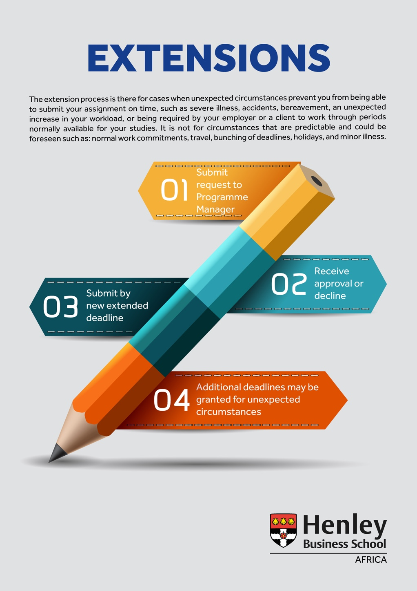

ORIGINAL WORK

The work submitted for the programme must be the delegates’ own work. Any part of it that is not carried out by the delegate (e.g. subcontracted research) must be referenced and agreed in advance.

REFERENCING

The Harvard Referencing style is to be used for referencing. A copy can be found on Pelopele (see below). A session should be held during the first contact block to highlight the importance of referencing and to inform the delegates of proper process where it is concerned. PDs should provide some examples and ensure understanding from delegates before the first paper is written.

Please also refer to the guidelines which will be posted on Pelopele.

PLAGIARISM
A signed plagiarism statement must be affixed to each and every delegate assignment. An electronic version will be found on Pelopele and a hard copy is contained in this delegate handbook. Plagiarism is viewed in an extremely serious light. All suspected plagiarism cases must be investigated and brought before the relevant internal Henley committee, in consultation with Frempong Acheampong, as Henley’s Academic Director, and Linda Buckley as Director of Executive Education.
Please refer to the below graphic regarding plagiarism.

ONLINE SUPPORT

To keep in touch with each other and with the Henley team, we have set-up a dedicated, online, portal for the programme, called Pelopele. Pelopele is a mechanism to stay in touch and allow you to have online interactions with each other in-between study blocks, with your facilitators and programme management team. It allows ‘closed-access’, i.e., restricted access to ensure company-confidentiality. The Henley Programme Manager will invite each delegate to register as a student.
We will allow you access to the programme on Pelopele. This will enable you to (inter alia):
- access all new announcements and logistical and operational notes
- peruse course material of all facilitators and guest speakers
- access delegate group information (under Group File Share if on Pelopele)
- access timetables, delegate lists, team lists per module etc
- access all digital hand-in folders and hand-in assignments and deliverables
- access blogs/fora allowing communication between delegates and yourself
- communicate optimally with colleagues and faculty.

GENERAL

PUNCTUALITY

Unless otherwise stated, class starts at 8h30 promptly and finishes by 17h00. There will be a morning and afternoon tea/coffee break, the times of which are provided daily by the Programme Manager, along with a luncheon. Learners are required to be punctual (on-time) for all class-start times provided. Evening sessions may also be scheduled throughout the Programme, which will communicated to you by the Programme Management Te

COMMUNICATION

Please ensure that your email address and telephone numbers are updated with the Programme Coordinator/Manager.

LANGUAGE

All faculty members will present their lectures in English. Similarly, all Henley correspondence, assignments, exam papers are conducted in English.

SECURITY AND INDEMNIFICATION

Henley will not be held responsible for any loss / fire / theft at any of its venues whether it is at Henley or outsourced. Please note that you indemnify the School of any damage caused by the learner to School/University property or to the property of third parties, whether on or off the School/university premises, as a result of the learner’s actions whilst on the School / University premises or whilst engaged in any activity related to the School/University.

PLAGIARISM DECLARATION FORM

Name

Company

Assessment Title
Date
Facilitator

Plagiarism Declaration

I declare that this coursework is entirely my own work and does not include any plagiarised material. All sources that were consulted to compile this document have been referenced appropriately.

Full name:

Signature:

Date:

